**401 - HTML Lists**

An **HTML List**allows you to organize data on web pages into an ordered or unordered format to make the information easier to read and visually appealing. HTML Lists are very helpful for creating structured, accessible content in web development.

**Types of HTML Lists**

There are three main types of lists in HTML:

1. **Unordered Lists (<ul>):**These lists are used for items that do not need to be in any specific order. The list items are typically marked with bullets.
2. **Ordered Lists (<ol>):** These lists are used when the order of the items is important. Each item in an ordered list is typically marked with numbers or letters.
3. **Description Lists (<dl>):** These lists are used to contain terms and their corresponding descriptions.

**Basic Example of HTML Lists**

<!DOCTYPE html>

<html>

<body>

  <h2>Welcome To ProdipAlways Learning</h2>

  <h5>List of available courses</h5>

  <ul>

    <li>Data Structures & Algorithm</li>

    <li>Web Technology</li>

    <li>Aptitude & Logical Reasoning</li>

    <li>Programming Languages</li>

  </ul>

  <h5>Data Structures topics</h5>

  <ol>

    <li>Array</li>

    <li>Linked List</li>

    <li>Stacks</li>

    <li>Queues</li>

    <li>Trees</li>

    <li>Graphs</li>

  </ol>

</body>

</html>

**Output:**

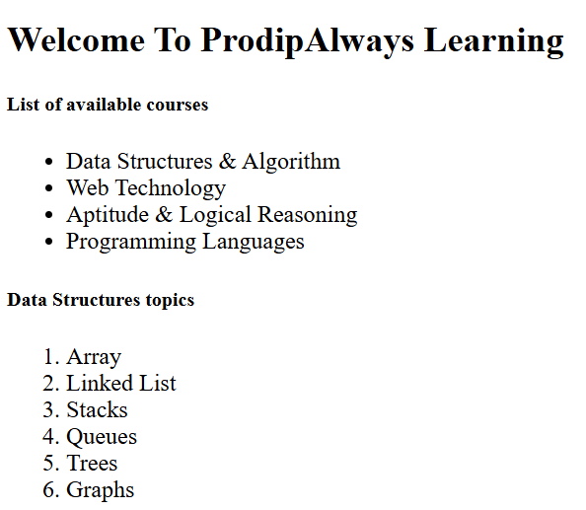

**HTML List Tags**

|  |  |
| --- | --- |
| **Tag** | **Description** |
| <ul> | Defines an unordered list. |
| <ol> | Defines an ordered list. |
| <li> | Defines a list item. |
| <dl> | Defines a description list. |
| <dt> | Defines a term in a description list. |
| <dd> | Details the term in a description list. |

**1. Using HTML Unordered List or Bulleted List**

Unordered lists are ideal for scenarios where the sequence of the items is not important.

The unordered list items are marked with bullets, also known as bulleted lists. An unordered list starts with the <ul> tag, and each list item begins with the <li> tag.

**Syntax:**

<ul>

<li>Item 1</li>

<li>Item 2</li>

<li>Item 3</li>

</ul>

**Attribute:** This tag contains two attributes which are listed below:

* **compact:** It will render the list smaller.
* **type:** It specifies which kind of marker is used in the list.

**Example:**

This example describes the unordered list.

<!DOCTYPE html>

<html>

<body>

  <h2>Grocery list</h2>

  <ul>

    <li>Bread</li>

    <li>Eggs</li>

    <li>Milk</li>

    <li>Coffee</li>

  </ul>

</body>

</html>

**Output:**

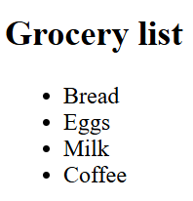

**2. Using HTML Ordered List**

Ordered lists are used when the items need to follow a specific sequence.

In an ordered list, all list items are marked with numbers by default. An ordered list starts with the <ol> tag, and each list item begins with the <li> tag.

<ol>

<li>Item1</li>

<li>Item2</li>

<li>Item3</li>

</ol>

**Attributes:**

* **compact:** It defines the list should be compacted (compact attribute is not supported in HTML5. Use CSS instead.).
* **reversed:** It defines that the order will be descending.
* **start:** It defines from which number or alphabet the order will start.
* **type:** It defines which type(1, A, a, I, and i) of the order you want in your list of numeric, alphabetic, or roman numbers.

**Example:**

This example describes the ordered list with the use of reverse, type, and start attribute.

<!DOCTYPE html>

<html>

<head>

  <title>HTML ol tag</title>

</head>

<body>

  <h1 style="color: green">ProdipAlways</h1>

  <h3>HTML ol tag</h3>

  <p>reversed attribute</p>

  <ol reversed>

    <li>HTML</li>

    <li>CSS</li>

    <li>JS</li>

  </ol>

  <p>start attribute</p>

  <ol start="5">

    <li>HTML</li>

    <li>CSS</li>

    <li>JS</li>

  </ol>

  <p>type attribute</p>

  <ol type="i">

    <li>HTML</li>

    <li>CSS</li>

    <li>JS</li>

  </ol>

</body>

</html>

**Output:**

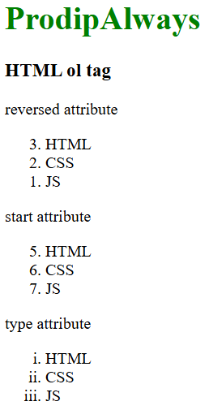

**3. Using HTML Description List**

A description list is a list of terms, with a description of each term. Description lists are less common but very useful for definitions, glossaries, or any other key-value pairs of items.

The <dl> tag defines the description list, the <dt> tag defines the term name, and the <dd> tag describes each term.

**Syntax:**

<dl>

<dt>Item 1</dt>

<dd>Description of Item 1 </dd>

<dt>Item 2</dt>

<dd>Description of Item 2</dd>

</dl>

Here, <dt> (description term) is used for the term being defined, and <dd> (description details) is used for the description.

**Example:**

This example describes the HTML Description List.

<!DOCTYPE html>

<html>

<body>

  <h2>A Description List</h2>

  <dl>

    <dt>Coffee</dt>

    <dd>- 500 gms</dd>

    <dt>Milk</dt>

    <dd>- 1 ltr Tetra Pack</dd>

  </dl>

</body>

</html>

**Output:**

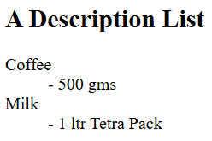

**Best Practices for Using HTML Lists**

* **Semantic Correctness**: Always use the appropriate type of list for your content to ensure semantic correctness and improve accessibility.
* **Nesting Lists**: HTML lists can be nested inside one another. For example, you can place an unordered list inside an ordered list item to create a hierarchy.
* **Styling Lists**: Use CSS to style lists to match the design of your website. You can change bullet styles in unordered lists, the numbering style in ordered lists, and more.
* **Accessibility**: Make sure your lists are accessible. Properly structured lists help screen readers interpret the content accurately, enhancing the accessibility of your website.

**402 - HTML Ordered Lists**

**HTML Ordered List**is created by the HTML **<ol> tag**, to display elements in an ordered form, either numerical or alphabetical. Each item within the list is placed within a <li> tag, which stands for “list item”.

The list is automatically numbered by the browser, but the style of numbering can be adjusted using attributes and CSS.

**Syntax**:

<ol>  
 <li>...</li>  
 <li>...</li>  
 <li>...</li>  
</ol>

**Example – Creating a Basic Ordered List**

<!DOCTYPE html>

<html>

<head>

  <title>Simple Ordered List</title>

</head>

<body>

  <h2>My To-Do List</h2>

  <ol>

    <li>Go grocery shopping</li>

    <li>Pay utility bills</li>

    <li>Prepare dinner</li>

  </ol>

</body>

</html>

**Output:**

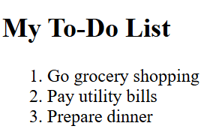

**HTML Ordered Lists – Type Attribute**

The type attribute of **<ol> tag** specifies the order we want to create.

|  |  |
| --- | --- |
| **Type** | **Descriptions** |
| type=”1″ | This will list the items with numbers (default) |
| type=”A” | This will list the items in uppercase letters. |
| type=”a” | This will list the items in lowercase letters. |
| type=”I” | This will list the items with uppercase Roman numbers. |
| type=”i” | This will list the items with lowercase Roman numbers. |

**1. Number – Ordered List**

To create an ordered list in HTML with numerical markers, which is the default behavior for ordered lists, you simply use the <ol> (ordered list) tag without specifying a type attribute.

**Example:**

<!DOCTYPE html>

<html>

<head>

  <title>Numbered List Example</title>

</head>

<body>

  <h2>Ordered List with Numbers</h2>

  <ol>

    <li>JavaScript</li>

    <li>Python</li>

    <li>Java</li>

    <li>C++</li>

    <li>C#</li>

  </ol>

</body>

</html>

**Output:**

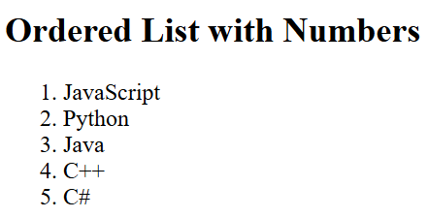

**2. Uppercase Letters – Ordered List**

To create an ordered list in HTML that uses uppercase letters for the list markers, you can use the type attribute on the <ol> tag and set it to "A".

**Example:**

<!DOCTYPE html>

<html>

<head>

  <title>

    Uppercase Letters Ordered List

  </title>

</head>

<body>

  <h2>Uppercase Letters Ordered List</h2>

  <ol type="A">

    <li>Apple</li>

    <li>Banana</li>

    <li>Cherry</li>

    <li>Date</li>

  </ol>

</body>

</html>

**Output:**

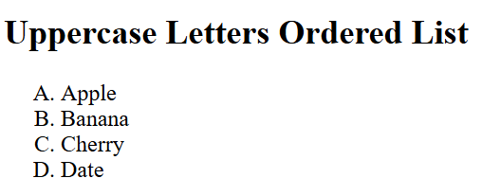

**3. Lowercase Letters – Ordered List**

To create an ordered list in HTML that uses lowercase letters for the list markers, you can use the type attribute on the <ol> tag and set it to "a".

**Example:**

<!DOCTYPE html>

<html>

<head>

  <title>

    Lowercase Letters Ordered List

  </title>

</head>

<body>

  <h2>Lowercase Letters Ordered List</h2>

  <ol type="a">

    <li>RCB</li>

    <li>CSK</li>

    <li>DC</li>

    <li>MI</li>

  </ol>

</body>

</html>

**Output:**

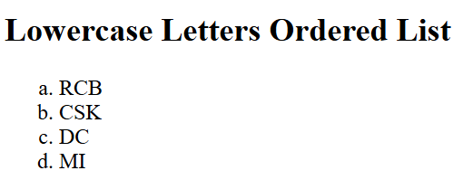

**4. Uppercase Roman Numbers – Ordered List**

To create an ordered list in HTML with uppercase Roman numerals as the markers, you can use the type attribute on the <ol> tag and set it to “I”.

**Example:**

<!DOCTYPE html>

<html>

<head>

  <title>

    Uppercase Roman Numbers Ordered List

  </title>

</head>

<body>

  <h2>

    Uppercase Roman Numbers Ordered List

  </h2>

  <ol type="I">

    <li>First item</li>

    <li>Second item</li>

    <li>Third item</li>

    <li>Fourth item</li>

  </ol>

</body>

</html>

**Output:**

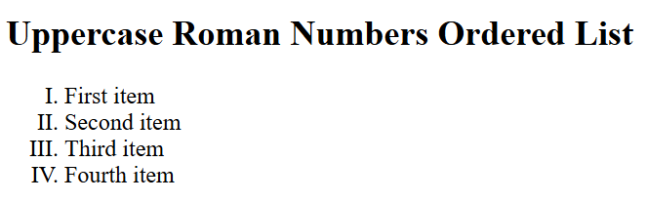

**5. Lowercase Roman Numbers – Ordered List**

To create an ordered list in HTML with lowercase Roman numerals as the markers, you can use the type attribute on the <ol> tag and set it to “i”.

**Example:**

<!DOCTYPE html>

<html>

<head>

  <title>

    Lowercase Roman Numbers Ordered List

  </title>

</head>

<body>

  <h2>

    Lowercase Roman Numbers Ordered List

  </h2>

  <ol type="i">

    <li>First item</li>

    <li>Second item</li>

    <li>Third item</li>

    <li>Fourth item</li>

  </ol>

</body>

</html>

**Output:**

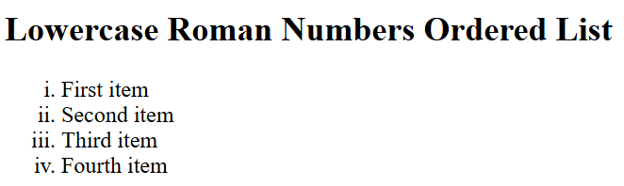

**–> Reverse Ordered List in HTML**

To create a reverse-ordered list in HTML, you can **use the ‘reversed' attribute in the <ol> tag**. This will make the list count down from the highest number.

**Example:**

<!DOCTYPE html>

<html>

<head>

  <title>Reverse Ordered List</title>

</head>

<body>

  <h1>Top 5 Movies to Watch</h1>

  <ol reversed>

    <li>The Shawshank Redemption</li>

    <li>The Godfather</li>

    <li>Inception</li>

    <li>Interstellar</li>

    <li>Pulp Fiction</li>

  </ol>

</body>

</html>

**Output:**

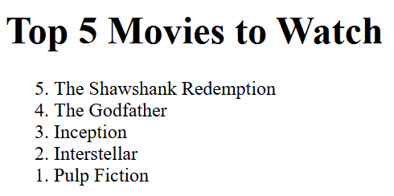

**–> Control List Counting**

To control list counting, **use the ‘start’ attribute in the <ol> tag**to set the starting number for the ordered list.

**Example:**In this example we showcase an ordered list starting from the number 5, controlled by the “start” attribute within the <ol> tag, customizing list counting

<!DOCTYPE html>

<html>

<head>

  <title>Control List Counting</title>

</head>

<body>

  <h2>Control List Counting</h2>

  <ol start="5">

    <li>Item 5</li>

    <li>Item 6</li>

    <li>Item 7</li>

    <li>Item 8</li>

  </ol>

</body>

</html>

**Output:**

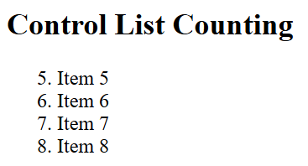

**–> Nested Ordered Lists**

Nested ordered lists **use <ol> inside <li> tags** to create sublists, making content more organized.

**Example:**In this example we are creating nested ordered list, listing programming languages with their respective frameworks as subitems

<!DOCTYPE html>

<html>

<head>

  <title>Nested Ordered List</title>

</head>

<body>

  <h2>Nested Ordered List</h2>

  <ol>

    <li>

      JavaScript

      <ol>

        <li>React</li>

        <li>Angular</li>

        <li>Vue.js</li>

      </ol>

    </li>

    <li>

      Python

      <ol>

        <li>Django</li>

        <li>Flask</li>

        <li>Pyramid</li>

      </ol>

    </li>

  </ol>

</body>

</html>

**Output:**

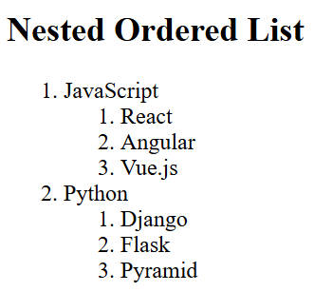

**403 - HTML Unordered Lists**

An **HTML Unordered List** is defined with the **<ul> tag**, where “ul” stands for “unordered list.” Each item within the list is marked by a <li> tag, standing for “list item.”

The items in an unordered list are typically displayed with bullet points, which can be styled or changed using CSS.

**Syntax:**

**<ul>**  
 <li>Item 1</li>  
 <li>Item 2</li>  
**</ul>**

**HTML Unordered Lists Examples**

Below are some examples showing the use of HTML Unordered lists.

**Example 1:**

<!DOCTYPE html>

<html>

<head>

  <title>

    HTML Unordered Lists

  </title>

</head>

<body>

  <h2>HTML Unordered Lists</h2>

  <ul>

    <li>HTML</li>

    <li>CSS</li>

    <li>Javascript</li>

    <li>React</li>

  </ul>

</body>

</html>

**Output:**

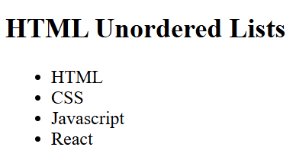

**Unordered Lists Style Types**

|  |  |
| --- | --- |
| **Values** | **Descriptions** |
| disc | This value sets the list marker to a bullet (default). |
| circle | This value sets the list marker to a circle. |
| square | This value sets the list marker to a square. |
| none | This value unmarks the list of items. |

**Example 2:**Implementation of**list style type** to **square** in unordered lists.

<!DOCTYPE html>

<html>

<head>

  <title>

    Square type unordered list

  </title>

</head>

<body>

  <h2>Square type unordered list</h2>

  <ul style="list-style-type: square">

    <li>HTML</li>

    <li>CSS</li>

    <li>Javascript</li>

    <li>React</li>

  </ul>

</body>

</html>

**Output:**

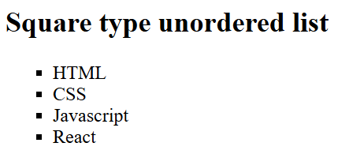

**Example 3:** Implementation of **list style type** to a **circle**.

<!DOCTYPE html>

<html>

<head>

  <title>

    Circle type unordered list

  </title>

</head>

<body>

  <h2> Circle type unordered list</h2>

  <ul style="list-style-type:circle;">

    <li>HTML</li>

    <li>CSS</li>

    <li>Javascript</li>

    <li>React</li>

  </ul>

</body>

</html>

**Output:**

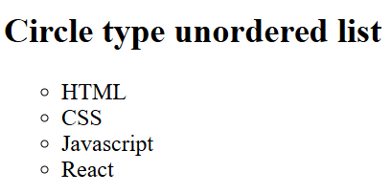

**Example 4:** Implementation of **list style type** to **none** in unordered lists.

<!DOCTYPE html>

<html>

<head>

  <title>

    None type unordered list

  </title>

</head>

<body>

  <h2>None type unordered list</h2>

  <ul style="list-style-type:none;">

    <li>HTML</li>

    <li>CSS</li>

    <li>Javascript</li>

    <li>React</li>

  </ul>

</body>

</html>

**Output:**

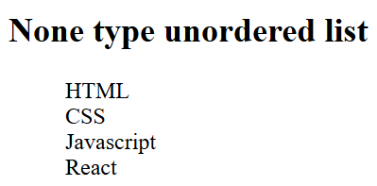

**–> Nested Unordered List**

An Unordered List can be nested, i.e., the list can be defined inside of another list.

**Example:**

<!DOCTYPE html>

<html>

<head>

  <title>Nested unordered list</title>

</head>

<body>

  <h2>Nested unordered list</h2>

  <ul>

    <li>Prodip</li>

    <li>

      Web Development

      <ul>

        <li>HTML</li>

        <li>CSS</li>

      </ul>

    </li>

    <li>Javascript</li>

  </ul>

  <ul type="square">

    <li>HTML</li>

    <li>CSS</li>

    <li>Javascript</li>

  </ul>

</body>

</html>

**Output:**

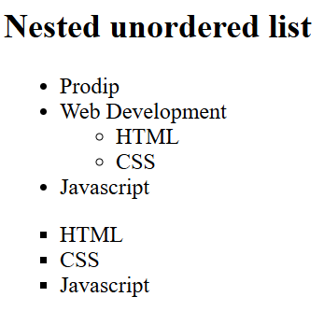

**–> Horizontal Unordered List**

An Unordered list can also be aligned in the Horizontal manner, which acts similar to the Nav bar.

**Example:**Implementation of Unordered List horizontally.

<!DOCTYPE html>

<html>

<head>

  <title>HTML Horizontal Unordered List</title>

  <style>

    body {

      text-align: center;

    }

    ul {

      overflow: hidden;

      background-color: #1d6b0d;

      list-style-type: none;

    }

    li {

      float: left;

    }

    li a {

      text-decoration: none;

      color: white;

      padding: 0.5rem;

    }

  </style>

</head>

<body>

  <h3>HTML Horizontal Unordered List</h3>

  <ul>

    <li><a href="#course">Course</a></li>

    <li><a href="#Blog">Blogs</a></li>

    <li>

      <a href="#Content">Content</a>

    </li>

  </ul>

</body>

</html>

**Output:**

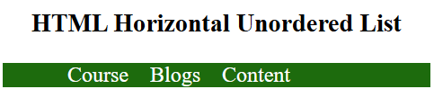

**Use Cases of Unordered Lists**

Unordered lists are incredibly versatile. Here are some common use cases:

* **Navigation Menus**: Many web designers use unordered lists to structure horizontal and vertical navigation menus.
* **Product Features**: Highlighting product features in bullet points for easy scanning.
* **Content Breakdown**: Breaking down complex content into bullet points to improve comprehension.

**404 - HTML Description Lists**

An **HTML Description List**is not as commonly used as unordered or ordered lists but serves an important purpose for displaying name-value pairs. This type of list is marked up using three tags: **<dl>, <dt>,**and**<dd>**.

* **<dl> (Description List):** This tag defines the description list itself and acts as a container for the list items.
* **<dt> (Description Term):** Represents a term or a name within the list.
* **<dd> (Description Details):**Provides the description or definition of the term.

**Syntax:**

<dl>

<dt>Coffee</dt>

<dd>A hot drink made from roasted coffee beans.</dd>

<dt>Espresso</dt>

<dd>Strong coffee brewed with steam through ground beans.</dd>

</dl>

**HTML Description Lists Examples**

**Example 1:**In this example, we demonstrate a description list with terms and their descriptions.

<!DOCTYPE html>

<html>

<head>

  <title>Description Lists Example</title>

</head>

<body>

  <h2>HTML Description Lists</h2>

  <dl>

    <dt>HTML</dt>

    <dd>

      HyperText Markup Language

    </dd>

    <dt>CSS</dt>

    <dd>

      Cascading Style Sheets

    </dd>

    <dt>JavaScript</dt>

    <dd>

      Scripting language for Web pages

    </dd>

  </dl>

</body>

</html>

**Output:**

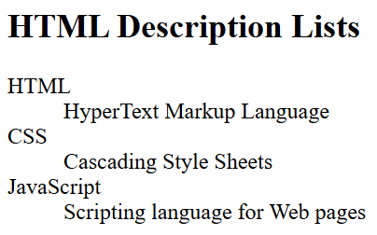

**Nested Description List**

A nested description list is when we add a description list inside another description list. This allows for organizing related terms and their definitions in a hierarchical structure, as demonstrated in the example:

**Example 2:**

<!DOCTYPE html>

<html>

<head>

  <title>Nested Description List</title>

</head>

<body>

  <h3>Technology Overview</h3>

  <dl>

    <dt>Hardware</dt>

    <dd>Physical devices</dd>

    <dd>

      <dl> <!-- Nested Description List for Hardware Types -->

        <dt>CPUs</dt>

        <dd>Processors</dd>

        <dt>GPUs</dt>

        <dd>Graphics</dd>

      </dl>

    </dd>

    <dt>Software</dt>

    <dd>Programs/Apps</dd>

    <dd>

      <dl> <!-- Nested Description List for Software Types -->

        <dt>System</dt>

        <dd>OS</dd>

        <dt>Application</dt>

        <dd>Tools</dd>

      </dl>

    </dd>

  </dl>

</body>

</html>

**Output:**

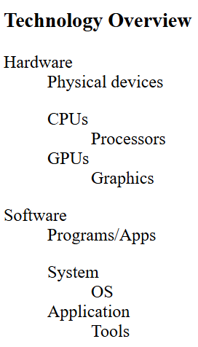

**405 - HTML li Tag**

The <li> (list item) tag in HTML is used to define individual items in a list. It can be used within an Ordered List (<ol>) or Unordered List (<ul>) or description lists <dl>. Each <li> represents a single item within these lists, helping to structure content and make it more readable and accessible.

<!DOCTYPE html>

<html>

<body>

  <h1>Shopping List</h1>

  <ul>

    <li>Apples</li>

    <li>Bananas</li>

    <li>Oranges</li>

  </ul>

  <h1>To-Do List</h1>

  <ol>

    <li>Buy groceries</li>

    <li>Complete homework</li>

    <li>Walk the dog</li>

  </ol>

</body>

</html>

**Output:**

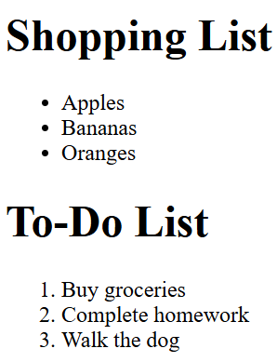

**Note:** The end tag can be omitted if the list item is immediately followed by another <li> element, or if there is no more content in its parent element.

**Syntax**

<ul>  
 <li>Item 1</li>  
 <li>Item 2</li>  
 <li>Item 3</li>  
</ul>  
  
<ol>  
 <li>First Item</li>  
 <li>Second Item</li>  
 <li>Third Item</li>  
</ol>

**Attribute Value**

**value:**The value attribute is used to specify the starting number of the list item. The list item starts from this number and increments its value with every addition of items to it. The value attribute only works for the ordered lists i.e. <ol> tag.

<!DOCTYPE html>

<html>

<body>

  <h1>Shopping List</h1>

  <ul>

    <li>Apples</li>

    <li>Bananas</li>

    <li>Oranges</li>

  </ul>

  <h1>To-Do List</h1>

  <ol>

    <li value="4">Buy groceries</li>

    <li>Complete homework</li>

    <li>Walk the dog</li>

  </ol>

</body>

</html>

**Output:**

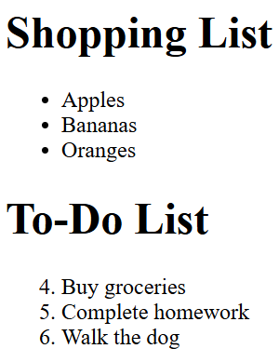

**406 - HTML ul Tag**

The **HTML <ul> tag** defines an unordered (bulleted) list. Use the <ul> tag together with the <li> tag to create unordered lists. List items (<li>) are nested within <ul>, allowing the display of items without a specific order, typically represented by bullet points in browsers.

<!DOCTYPE html>

<html>

<body>

  <h2>Laptop accessories</h2>

  <ul>

    <li>Mouse</li>

    <li>Keyboard</li>

    <li>Speaker</li>

    <li>Monitor</li>

  </ul>

</body>

</html>

**Output:**

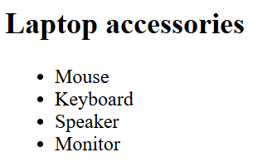

**Attributes**

|  |  |
| --- | --- |
| **Attribute** | **Description** |
| HTML <ul> compact Attribute | Renders the list smaller. |
| HTML <ul> type Attribute | Specifies the kind of marker used in the list. Values include disc, circle, square, etc. |

**Note:** The <ul> attributes are not supported by HTML 5.

**Types of List Styles:**

The list-style-type property defines the type of bullets:

* **disc (default):** Solid round bullets.
* **circle:** Hollow bullets.
* **square:** Square bullets.
* **none:** No bullets.

<!DOCTYPE html>

<html>

<head>

  <style>

    ul {

      list-style-type: square;

      padding: 0;

    }

  </style>

</head>

<body>

  <h1>Grocery List</h1>

  <ul>

    <li>Apples</li>

    <li>Bananas</li>

    <li>Carrots</li>

    <li>Bread</li>

  </ul>

</body>

</html>

**Output:**

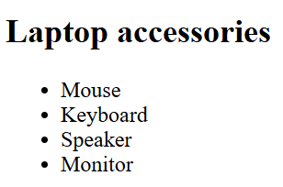

**Nested unordered list**

A nested unordered list allows creating multi-level hierarchies by placing a <ul> inside an <li>.

<!DOCTYPE html>

<html>

<head>

  <title>Nested unordered list</title>

</head>

<body>

  <h2>Welcome To ProdipAlways</h2>

  <ul>

    <li>Hardware</li>

    <li>

      Software

      <ul>

        <li>System Software</li>

        <li>Application Software</li>

      </ul>

    </li>

    <li>MacBook</li>

  </ul>

</body>

</html>

**Output:**

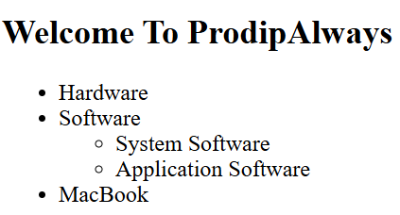

**407 - HTML <ol> Tag**

The**HTML <ol> tag** defines an ordered list. An ordered list can be numerical or alphabetical. It’s a fundamental HTML element used for structuring content and providing sequential organization. The numbering format can be customized using attributes like type and start, ensuring flexibility in list presentation.

**Syntax:**

<ol>  
 <li>Item1</li>  
 <li>Item2</li>  
 <li>Item3</li>  
</ol>

**Accepted attributes:**

|  |  |
| --- | --- |
| **Attribute** | **Description** |
| **compact** | Defines that the list should be compacted. Use CSS instead of the compact attribute in HTML5. |
| **reversed** | Defines that the order of the list items should be descending (from high to low). |
| **start** | Defines the starting number or alphabet for the ordered list. |
| **type** | Defines the type of order for the list items. Options include numeric (1, 2, 3…), alphabetic (A, B, C…), lowercase alphabetic (a, b, c…), uppercase Roman numerals (I, II, III…), and lowercase Roman numerals (i, ii, iii…). |

**HTML <ol> Tag Examples**

**Example 1:**In this example, The <ol> tag in HTML creates an ordered list where each item is automatically numbered. here we have created an ordered list of Frontend Technologies.

<!DOCTYPE html>

<html>

<head>

  <title>HTML Ordered Lists</title>

</head>

<body>

  <h2>Welcome To ProdipAlways</h2>

  <ol>

    <li>HTML</li>

    <li>CSS</li>

    <li>JavaScript</li>

    <li>React.Js</li>

  </ol>

</body>

</html>

**Output:**

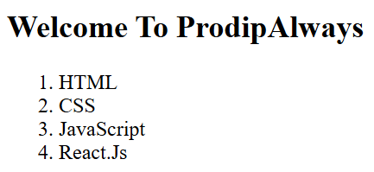

**Example 2:** This example The <ol> tag in HTML creates an ordered list. The `reversed` attribute reverses the numbering, start sets the starting number, and `type` defines the numbering style ‘i’ for Roman numerals.

<!DOCTYPE html>

<html>

<head>

  <title>HTML ol tag</title>

</head>

<body>

  <h1 style="color:green;">

    ProdipAlways

  </h1>

  <h3>HTML ol tag</h3>

  <p>reversed attribute</p>

  <ol reversed>

    <li>HTML</li>

    <li>CSS</li>

    <li>JS</li>

  </ol>

  <p>start attribute</p>

  <ol start=5>

    <li>HTML</li>

    <li>CSS</li>

    <li>JS</li>

  </ol>

  <p>type attribute</p>

  <ol type="i">

    <li>HTML</li>

    <li>CSS</li>

    <li>JS</li>

  </ol>

</body>

</html>

**Output:**

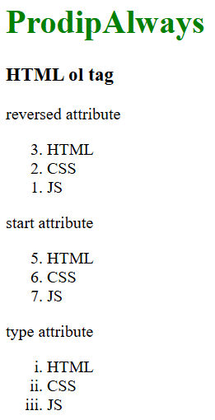

**408 - HTML dl Tag**

The**<dl> tag in HTML** is used to represent the description list. This tag is used with <dt> and <dd> tag to create a list of terms and their associated descriptions.

**Elements inside dl tag:**

* **<dt>:** Defines a term in the list.
* **<dd>:** Provides the description or definition of the term.

<!DOCTYPE html>

<html>

<body>

  <h2>dl Tag</h2>

  <dl>

    <dt>Item 1</dt>

    <dd>This is description for item 1</dd>

    <dt>Item 2</dt>

    <dd>This is description for item 2</dd>

  </dl>

</body>

</html>

**Output:**

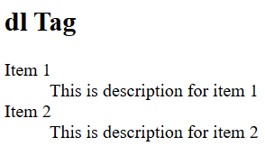

**Common Use Cases:**

* **Glossaries:** Listing terms and their definitions.
* **FAQs:** Organizing questions and answers.
* **Metadata:** Describing key-value pairs, like technical specifications.

**Styling dl Tag**

<!DOCTYPE html>

<html lang="en">

<head>

  <style>

    dl {

      background: #fff;

      border: 1px solid #ccc;

      border-radius: 5px;

      padding: 15px;

      box-shadow: 0 2px 5px rgba(0, 0, 0, 0.1);

    }

    dt {

      font-weight: bold;

      color: #2c3e50;

      margin-top: 10px;

    }

    dd {

      margin-left: 20px;

      color: #34495e;

      margin-bottom: 10px;

    }

  </style>

</head>

<body>

  <h1>Fruits</h1>

  <dl>

    <dt>Apple</dt>

    <dd>

      A sweet, edible fruit produced by an apple tree.

    </dd>

    <dt>Banana</dt>

    <dd>

      A long, curved fruit that grows in clusters and has soft,

      pulpy flesh and yellow skin when ripe.

    </dd>

    <dt>Cherry</dt>

    <dd>A small, round fruit that is typically red or black and

      has a pit in the center.

    </dd>

  </dl>

</body>

</html>

**Output:**

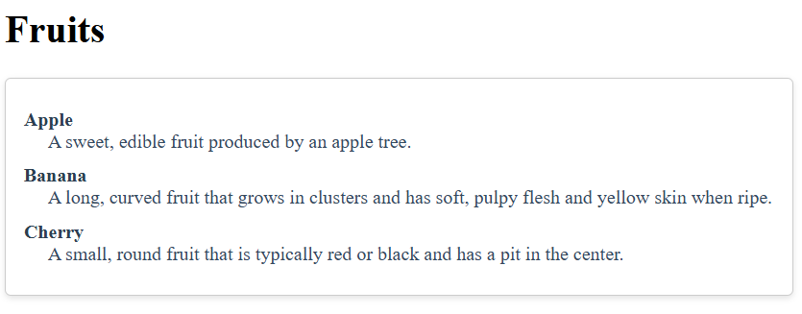

**409 - HTML dt Tag**

The <dt> tag in HTML is used to specify the description list. It is used inside the <dl> element. It is usually followed by a <dd> tag. The subsequent <dd> elements provides some related text associated with the term specified using <dt>.

**Syntax:**

<dt> Content... </dt>

**Example:** In this example, we are using the <dt> (definition term) tag within a <dl> (description list). It lists terms like “Geeks Classes,” “Fork Python,” and “Interview Preparation,” each with corresponding descriptive details.

<!DOCTYPE html>

<html>

<body>

  <h1>ProdipAlways</h1>

  <h2>&lt;dt&gt; Tag</h2>

  <dl>

    <!-- HTML dt tag -->

    <dt>Prodip Classes</dt>

    <dd>It is an extensive classroom programme for

      enhancing DS and Algo concepts.</dd><br>

    <!-- HTML dt tag -->

    <dt>Fork Python</dt>

    <dd>It is a course designed for beginners in

      python.</dd><br>

    <!-- HTML dt tag -->

    <dt>Interview Preparation</dt>

    <dd>It is a course designed for preparation of

      interviews in top product based companies.</dd>

  </dl>

</body>

</html>

**Output:**

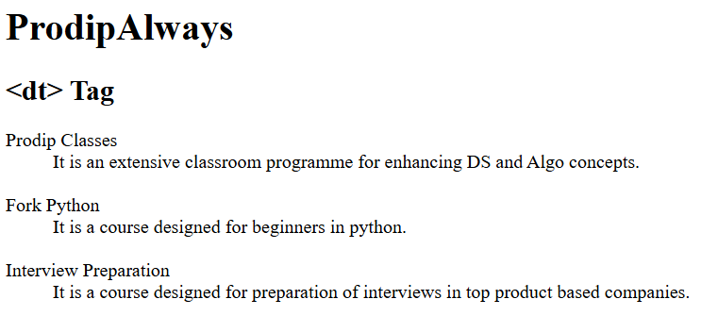

**410 - HTML dd Tag**

The <dd> tag in HTML is used to define a description or value in a description list, which is created using the <dl> (description list) tag. Each <dd> element is typically preceded by a <dt> (definition term) element, which specifies the term being described.

* **Semantic HTML:** The <dd> tag helps create a semantically meaningful structure in HTML documents, making it easier for search engines and assistive technologies to understand the content.
* Styling: By default, browsers typically indent the <dd> elements, making them visually distinct from the terms in <dt>. You can style these elements using CSS for further customization.

<!DOCTYPE html>

<html>

<body>

  <dl>

    <dt>Prodip Always</dt>

    <dd>It is an extensive classroom programme

      for enhancing DS and Algo concepts.</dd>

    <br>

    <dt>Fork Python</dt>

    <dd>It is a course designed for beginners

      in python.</dd>

    <br>

    <dt>Interview Preparation</dt>

    <dd>It is a course designed for preparation

      of interviews in top product based companies.</dd>

  </dl>

</body>

</html>

**Output:**

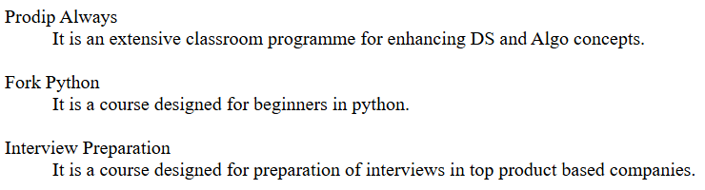

**Common Use Cases:**

* **Glossaries:** Listing terms and their definitions.
* **FAQs:** Organizing questions and answers.
* **Metadata:** Describing key-value pairs, like technical specifications.

**Default CSS for dd Tag:**

The default styling for dd tag

dd{

display: block;

margin-left: 40px;

}

<!DOCTYPE html>

<html>

<head>

  <style>

    dd {

      display: block;

      margin-left: 40px;

    }

  </style>

</head>

<body>

  <dl>

    <dt>Prodip Classes</dt>

    <dd>

      It is an extensive classroom programme

      for enhancing DS and Algo concepts.

    </dd>

  </dl>

</body>

</html>

**Output:**

